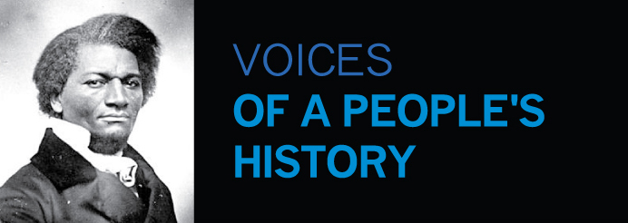

130 West 25th Street, Room 12A • New York, NY 10001-7472 • 212.366.9883

To Whom It May Concern:

I am writing at the request of NAME at INSTITUTION, so that a check may be released from the Voices fundraising project.

The Voices chapter at INSTITUTION is making a donation of XXX to Voices to support xxxxx.

If you have any questions or concerns, please fee free to contact me directly.

Anthony Arnove

Secretary-Treasurer
Voices of a People’s History of the United States
voices@peopleshistory.us
212-366-9883

